Software development coursework plan:

Introduction:
- Pick SWD method we will use and follow it, Waterfall?
  - Requirements
  - Design
  - Implement
  - Test
  - Evaluate

- Design a test system and put implemented system through them

- Program in OOP across multiple programs

- Recognise and evaluate different development practices and judge their appropriateness for a specific development problem.
  - Compare different SWD development lifecycles and pick one?
  - Assuming on a documentation file?

- Analyse and break down a problem into constituent parts. Compare and critically contrast different potential solutions to a problem.
  - Requirements and design?
  - Assuming on a documentation file?

- Follow the pair-programming development approach used widely in industry.
  - Driver and Passenger

What we need to do:
- Develop a multi-threaded card playing simulation
  - Implement thread safe Card class
  - Implement thread safe Player class
  - Develop an executable CardGame class
    - Acts as our main in essence, from my understanding
    - And we may need to add more classes.
  - Pack is a txt file. How do we generate a pack if needed and what is the rules regarding what makes a valid card in a pack and a valid pack.
  - Round robin algorithm? 1 round for hands, 1 round for decks. In that order respectively.

- Develop relevant tests
  - High marks require tests of behaviour and invariants, not primarily tests of getters/setters or superficial code coverage.
  - Code coverage alone is not sufficient evidence of a rigorous test suite.
  - Tests should only test observable behaviour through the public interface.
  - Relevant examples for tests:
    - FIFO deck behaviour
    - Maintaining exactly four cards in each player hand after a completed atomic action conservation of cards
    - Preferred-denomination discard behaviour
    - Valid and invalid input handling
    - Immediate-win detection
    - Clean termination after a winner
    - Generation of the required output files

- Do a write-up document: 4 pages max
  - Design rationale and critical report (3 pages max for this section?)
  - Testing overview and analysis
  - Development process and paired programming record(1 page max)

- No Javadoc needed.

The game:
- Has n players (1..n)
- Has n decks (1..n)
- Each player has a hand, containing 4 cards
- All of the decks and hands will be drawn from a pack of 8n cards
- Each card has a number assigned to it, a card’s number may exceed n.
- The hands and decks form a ring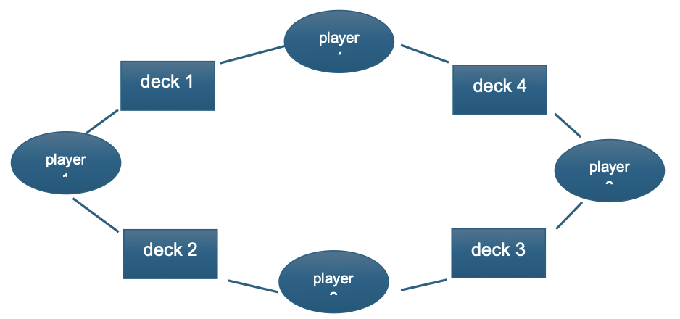
- At the start of the game, each player will be distributed four cards in a round-robin fashion.
- From the top of the pack, starting by giving one card to player1, then one card to player2, etc. After the hands have been distributed, the decks will then be filled from the remaining cards in the pack, again in a round-robin fashion.
  - Should the pack be shuffled beforehand, to prevent guaranteed wins/losses every time with the same amount of players, or is it in order to be predictable to mark
  - Is the round robin clockwise, starting from player 1?

Definitions:
- Deck:
  - A deck is an ordered, thread-safe container (FIFO) holding card denominations from the shared 8n pack. Players draw from the top (front) and discard to the bottom (back) of decks as specified by the ring topology (player i draws from deck i and discards to deck i+1). Draw and discard together are treated as one atomic action.
  - At game end, each player holds exactly four cards, and each deck’s final contents are written to deckX_output.txt (deck sizes may vary).
    - Aka Deck is a Queue data structure
    - Discard and Draw are a unified action, atomic.
    - At game end, each player holds 4 cards and each deck’s contents is written to deckX_output.txt, deck sizes can vary?
- Win condition:
  - Player needs 4 cards with same value in their hand
  - If a player starts off at this condition it needs to be declared before game start, by their thread printing “Player i wins”, i is the player’s assigned number, e.g: 1,2,3,4.
  - The player thread should notifiy the other threads and exit.
  - There is a chance that, two or more players are given four cards with the same value at the start of the game. You don’t need to handle this situation in your development.

- To reach win condition:
  - Each player picks a card from the top of the deck to their left and discards one to the bottom of the deck to their right.
    - By multi-threading, players should not play the game sequentially
  - This process continues until the first player declares that they have four cards of the same value, at which point the game ends
    - By multi-threading, there is a chance that, two or more players have their four cards of the same value at the same time. You don’t need to handle this situation in your development.

- Game playing strategy:
  - Each player will implement a simple strategy
  - Each player will prefer cards equal to their index value, p1 -> 1s, p2 -> 2s
  - After drawing (from their left), they then discard (to their right)
    - The discarded card must not be of their preference
    - A player must not hold onto a non-preferred card indefinitely, to prevent game stagnation (thus a random draw of their non preferred cards?)
    - Can a player win through a non preferred card, if they can’t hold onto it is it just pure chance they don’t discard them for long enough?

Solution Development:
- We must use a version-control system (assuming GitHub?) during development. Your submitted process evidence should show a coherent development history, including selected meaningful commits and the evolution of the implementation and testing. Marks are awarded for the quality of this evidence, not the number of commits.
- Executable class, CardGame.
  - Main method requests number of players and after receiving that it requests the location of a valid input pack.
- A valid input pack is a plain text file, where each row contains a single non-negative integer value, and has 8n rows. The screenshot below shows a partial pack Sceenshot below had the pack txt in the same directory so no path was required.
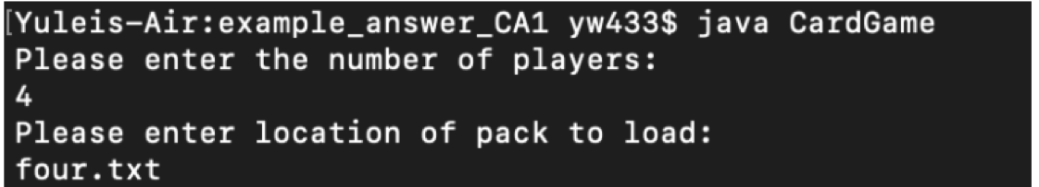
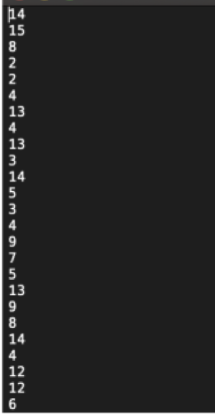

- After reading input pack, the CardGame class should distribute the hands to the players, fill the decks and start the required threads for the players.
- If a pack is invalid, the program will inform the user, and request a valid pack file.
  - Game cannot start without number of players and a valid pack
- Assuming a player does not start with a winning hand, as a player processes their hand, each of it’s actions should be printed to an output file, named after the player.
  - Eg: “player1_output.txt”, separate file for each player.
  - Game actions should also be printed the following structure
    - “player i draws a x from deck o”
    - “player i discards a x to deck o”
    - “player i current hand is w x y z ”
    - “player i initial hand is w x y z”

- Game end notification:
  - Each player ends with a hand of 4 cards, and should be 4 cards throughout due to the atomic nature of draw, discard.
  - At the end of the game the last lines of the file should read either:
  - “player i wins”
  - “player i exits”
  - “player i final hand: x x x x”
    - does x always have to equal i?
  - Or:
  - “player 3 has informed player 1 that player 3 has won”
  - “player 1 exits”
  - “player 1 hand 2 2 3 5”
  - In the case player 3 won.
  - Above text layout is from the CA document, it’s a bit confusing for the action tracking, will ask for clarification.
  - There should also be a message printed to terminal, such as “player 4 wins”
  - There is only 1 winner for a single game.
    - If it happens during development we do not need to resolve it.
  - If the game is won immediately (upon card hand out), the output files should still be written for all players (“although each file will only contain 4 lines”, why?)
  - In addition to the player_output.txt we also need n output files for each deck written at the end of the game(decki_output.txt)
    - This contains a single line of text, detailing the contents of the deck at the end of the game, e.g:
      - “deck2 contents: 1 3 5 7”

Solution requirements:
- Must include 2 files:
  - cards.jar – our code
    - Both .java and .class files
  - cardsTest.jar – Our tests?
    - Both .java and .class files
  - Full submission ZIP must contain:
    - our code, tests, “test suites”? and any supporting files
    - any testing files our tests rely upon
    - a README file, to give exact instructions on how to compile and run our test suite, including the JDK/Junit version and any required dependences
- In person individual code defence: after submission, we will individually undergo a 5-8 minute individual conversation with a member of the teaching team.
  - Will be asked to explain a submitted architecture, or code, reason about threat safety or a game scenario, diagnose a small defect, or describe or make a small change or test.
    - Marks may differ to each individual and you may refer to your submitted code during the conversation.
- Written Evidence: (Only first 4 pages will be marked. So 2:1:1 split?)
  - Minimum 2cm margins
  - 11-point text (font size?)
  - Must contain:
    - A design rationale and critical report, no more than 3 pages of A4, that explains:
      - Architecture of our code
      - Key OOP and Concurrency Decisions
      - Alternatives considered
      - Testing Strategy
      - Known limitations and performance issues
      - How the implementation meets the specification
      - Focus on rationale and evaluation rather than a description of individual methods
    - Explanation of design of our tests and the limitations of our testing approach, containing:
      - What JUnit version we are using, 4.x or 5.x,…
      - Testing overview
      - Our design
      - Our limitations with our testing approach
    - A development-process and paired programming record of no more that 1 side of A4.
      - Date, times, duration of sessions, the driver/navigator roles taken, 3-5 significant version control commits (commit identifier, + brief description of what changed, was tested, or debugged).
      - Serving as evidence for an authentic, iterative development process.
      - Marks are based on the qualify and coherence of the evidence, not the number of commits. Each pair-programming entry should be agreed upon by both members.

Marking:
- Group – 80% :
  - Implementation correctness, OOP design and Concurrency – 30%
  - Testing, robustness and software quality – 20%
  - Design rationale and critical report – 15%
  - Development process and pair-programming evidence – 10%
  - Packaging, reproducibility and README – 5%
- Individual – 20% :
  - Live individual code defence – 20%

